**SS/STDR**

**SS/STDR**

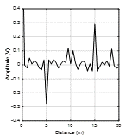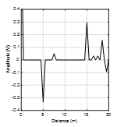

Traditional

Enhanced

Spread Spectrum Time Domain Reflectometry (SSTDR) for measuring a wiring network